Advocate – Temporary Full Time (Specific Purpose Contract).

Ennis, Clare, Western Region.

Candidate Pack

June 2022

Contents
NAS - What we do 3
Our Core Values 4
Regional layout & locations 5
Job description 6
Reports to 6
Responsibilities 6
Person specification 7
Minimum Educational Qualifications & Experience 7
Person specification 7
Required Competencies 8
Terms & Conditions 10
Salary 10
Pension 10
Annual Leave 10
Requirements 10
How to Apply 11

NAS - What we do

The National Advocacy Service for People with Disabilities (NAS) provides an independent, confidential and free, issues-based representative advocacy service.
We provide representative advocacy to people with disabilities, to ensure that their will and preferences are heard in decisions that affect their lives, in areas that include social services, health, accommodation, personal finances, legal issues and family and relationships.
We have a particular remit to work with people with disabilities who; live in residential services, live in inappropriate accommodation, attend day services, have communication differences, have limited natural supports or are isolated from their communities.
The National Advocacy Service for People with Disabilities is funded and supported by the Citizens Information Board (CIB) which has a mandate under the Citizens Information Act 2007 and Comhairle Act 2000 to support the provision of advocacy for people with disabilities.
The Patient Advocacy Service is provided under the auspices of the National Advocacy Service for People with Disabilities and was established in October 2019 following the awarding of the contract a competitive tendering process to NAS in 2018. The Patient Advocacy Service is an independent, free and confidential Service that provides information and support to people who want to make a complaint about an experience they have had in a HSE-funded public acute hospital, and in the aftermath of patient safety incidents.
Advocate Role

Advocates support people who meet the NAS access and eligibility criteria in enquiry and casework across a wide range of advocacy issues in many settings. Advocates network with their colleagues sharing information and peer support and are also supported by senior advocates and a regional manager in managing cases and ensuring access to advocacy for people with disabilities.
NAS advocates promote the service to a wide variety of stake holders and are supported by a suite of policies and a Code of Practice which underpin training and practice development within the service.

Our Core Values

Our Strategic Plan 2018-2021 establishes the following five Core Values that underpin the work of NAS and the Patient Advocacy Service.
- Independence
We work with the person independently of others and free from all conflicts of interest. The advocacy process is led and guided by the person.
- Autonomy
We support the right of the person to self-direction/ determination (i.e. to be in control of their own life) and to make informed decisions based on their will and preferences. We also empower people to have their complaints processed in a balanced, fair and transparent manner.
- Equality/Citizenship
We support the right of every person to assert and enjoy their human rights, to participate in society as an equal citizen and to fulfil their full potential within a life of their own choosing.
- Respect
We work with the person in a way which demonstrates respect for the person as an individual and for their privacy, dignity and autonomy. All staff, partners and directors of NAS and the Patient Advocacy Service will act in a way that demonstrates respect for the people who use our services and each other.
- Empowerment
We aim to facilitate the person to be an active participant in decisions which affect their life, through the way in which the advocacy process is carried out as well as the outcomes it seeks to achieve. We also aim to empower the person to make a complaint or engage with a review process and seek answers when things go wrong.

Are you interested in supporting these core values and advocating for the rights of people accessing health and social services? Read further regarding the role, job description and required competencies.

Regional layout & locations

NAS operates across 31 locations throughout Ireland and share premises with the Citizens Information Service (13), Money Advice and Budgeting Service (1), the Citizens Information Board (4) and others (13). This co-location enhances the referral of people between services.
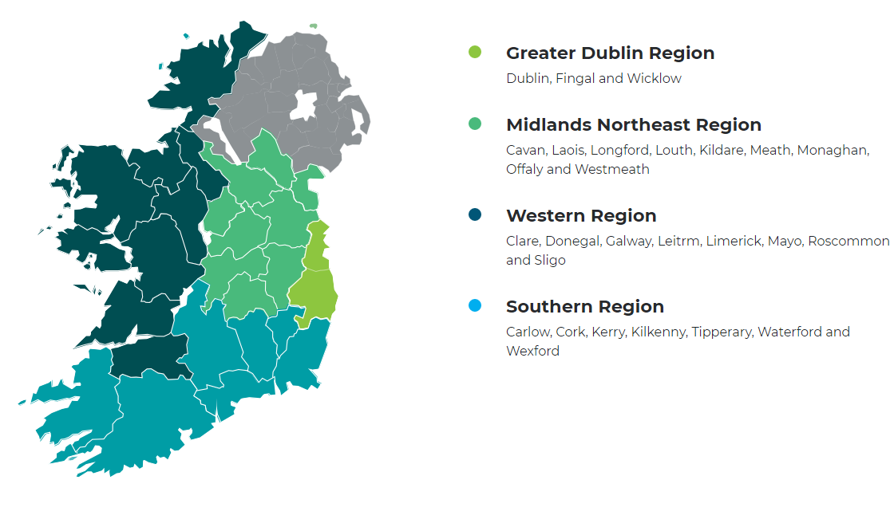

Job description

Reports to
Regional Manager

Responsibilities

Service Provision
- Assist, support and represent people with disabilities to seek a service, negotiating on their behalf and pursuing any right of review or appeal as required
- Work with people in residential and day service settings and with service providers to ensure people’s rights, dignity, choices and decisions are safeguarded
- Work as part of the regional advocacy team and share learning to improve practice and effect policy change
- Ensure that people with disabilities who need information, advice and advocacy are provided with the service that best supports their needs and that those with the capacity to self-advocate are supported to use mainstream services in their local community
- Identify and record issues that arise for people with disabilities to inform systemic changes in both the delivery and policy of public services
- Adhere to standardised policies, practice and quality standards.
- Provide peer support within the advocacy team and develop specialist expertise as required
- Work in co-operation with other advocates across the National Advocacy Service for People with Disabilities
- Effectively manage a caseload and keep accurate records using the electronic case management system, adhering to case management requirements
- Report on advocacy activities, and undertake review and evaluation as required by the Regional Advocacy Manager
- Observe data protection legislation and good practice in service provision
Additional Duties and Responsibilities
- Participate in special projects and joint working arrangements in consultation with the Regional Advocacy Manager
- Participate in mentoring activities
- Undertake promotional work on the National Advocacy Service and undertake other duties as directed by the Regional Advocacy Manager
- Develop and share knowledge of relevant legislation, appeals/redress mechanisms and social policy and practices in relation to advocating on behalf of people with disabilities
- Undertake appropriate training as required and ensure continuing professional development
- Undertake supervision of practice in line with service requirements
- Participate and work within a Performance Management Development System (PMDS) process

Person specification

Minimum Educational Qualifications & Experience
- Educated to graduate level in one or more of the following areas: social sciences, humanities, law, training and development. Equivalent experience and training will also be considered.

Desirable
- Advocacy qualification

Person specification

- An understanding and knowledge of the philosophy, background and operation of advocacy
- Awareness of the needs of people with disabilities and the barriers experienced in accessing rights and services.
- Ability to represent, negotiate and communicate on behalf of others
- Ability to understand and maintain confidentiality
- Ability to respect and promote people’s right to make informed decisions/choices
- Excellent judgement
- High degree of personal integrity
- Ability to organise one’s own workload, plan and set goals
- Ability to work effectively as part of a team
- Commitment to the rights of people with disabilities
- Flexibility of approach and flexibility to work unsocial hours when required and ability to travel efficiently throughout the region as requested.
Desirable
- Prior experience of representative advocacy with people with disabilities.
- Capacity to develop responses to policy submissions.

Required Competencies

NAS operates a competency based application and interview process, however there may be skills testing or a presentation involved in latter stages (this will be made known to those shortlisted).
The application form will ask you to write about your experiences in your career to date under several competencies and indicators. Use the below indicators to help you shape your responses, ensuring you clearly list employers (if applicable) and times of the experiences.

Competency | Indicator (not exhaustive)
- Specialist Knowledge/ Self development and upskilling in this area. | - Knowledge of the legislative, policy and regulatory framework in relation to disability.  - Ability to clearly identify breaches of current legislation/ peoples rights  - Evidence of awareness of disability sector and developments underway or under consideration in the sector  - Knowledge of legislation and policy frameworks regarding health and/or welfare rights issues for other marginalised groups.  - Constantly learns from experience and takes the initiative to develop new skills and expertise through research, learning and training.
- Ability to advocate on behalf of people with disabilities | - Understanding of principles of advocating on behalf of others  - Experience of providing representative advocacy to people with, including advocating on behalf of people who have communication differences.  - Experience of working with people in residential and day service settings and with service providers  - Ability to negotiate effectively on behalf of people
- Ability to review, monitor and evaluate, and organisation/administrative skills | - Constructively monitors and evaluates own performance/project work  - Identifies appropriate means of enhancing performance/ outcomes  - Experience of using case management system  - Efficient organisation and management of own time and caseload.  - Effectively uses available IT resources to deal efficiently with workload  - Keeps accurate and up to date records in line with data protection requirements
- Ability to Identify Policy Issues | - Ability and experience to observe and correctly identify policy issues.  - Able to report on and highlight such issues to create improvements in service provision.
- Communication Skills/Team Work | - Demonstrates excellent communication skills, written and spoken.  - Experience of making presentations to a variety of audiences  - Is an effective team member and fits into the team well.  - Balances personal objectives with those of the team  - Shares work-related knowledge with team members
- Drive & Commitment to NAS Core Values | - Can demonstrate commitment to values similar or the same as the NAS Core Values of Independence, Autonomy, Equality/Citizenship, Respect and Empowerment (see page 4) in personal and/or professional life.  - Ensures the citizen is at the heart of all services provided.  - Is personally honest and trustworthy and can be relied upon.  - Through leading by example, fosters the highest standards of ethics and integrity.

Terms & Conditions

- Advocate Full Time Permanent
- Advocate – Temporary Full Time Specified Purpose Contract

Salary
€42,658 – €46,195 (Pro Rata).

It is expected, that all new entrants to NAS will be appointed at point one of the salary scale, however the NAS operates an incremental credit process for appointments higher than point one. This process is applicable to new entrants into NAS. Incremental credit criteria, based on the competencies for the role, are assessed against employment history as laid out in the application form only. A request for incremental credit from a successful candidate must be made within the first 3 months of employment.

Pension
A company pension scheme is in place, and membership is obligatory upon commencement. Employee contribution; 5% of salary, Employer contribution; 7% of salary. NAS has a normal retirement age linked to the State Pension Age (currently 66).

Annual Leave
23 days per leave year (January to December)

Requirements
- The position entails some travel; therefore access to use of a car is a requirement for the post.
- The Advocate will be asked to obtain Garda Clearance before they begin work.

How to Apply

- A relevant application form can be accessed at www.advocacy.ie
- Applicants must meet the minimum criteria for the role set out in the person specification and possess all required competencies and will be shortlisted solely on the basis of information provided in their completed application form.
- Applicants should indicate which post they are applying for.
- Curriculum Vitae (CVs), late, incomplete or hand-written applications will not be considered.
- Please contact recruitment@advocacy.ie if you have any special requirements in relation to completing the application form.
- Closing date: 5.00pm 1st July 2022.
- Please email application form to: recruitment@advocacy.ie and place Reference 2022ADVROSC in the subject line.
- A regional panel of qualified candidates may be formed from which temporary full-time Advocate posts which arise in the Western Region in a specified period, up to a maximum of 12 months, will be filled.
- For information on how your personal data will be used as part of this process please refer to our Data Protection Notice for Job Applicants, available at the following link:

https://www.citizensinformationboard.ie/en/data_protection/nas.html

National Advocacy Service for People with Disabilities is an equal opportunities employers.

