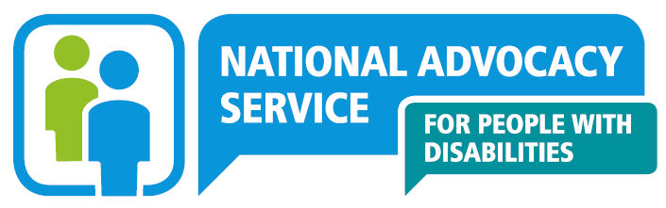

Senior Advocate
Greater Dublin Region

(Specified Purpose Contract)

Candidate Pack

October 2022 (Re-advertised Nov 2022)

Contents
NAS - What we do 3
Our Core Values 4
Regional layout & locations 5
Job description 6
Reports to 6
Responsibilities 6
Person specification 8
Minimum Educational Qualifications & Experience 8
Essential Knowledge & Skills 8
Required Competencies 9
Terms & Conditions 10
Salary 10
Location 10
Pension 10
Annual Leave 10
Requirements 10
How to Apply 11

NAS - What we do

The National Advocacy Service for People with Disabilities (NAS) provides an independent, confidential and free, issues-based representative advocacy service.
We provide representative advocacy to people with disabilities, to ensure that their will and preferences are heard in decisions that affect their lives, in areas that include social services, health, accommodation, personal finances, legal issues and family and relationships.
We have a particular remit to work with people with disabilities who; live in residential services, live in inappropriate accommodation, attend day services, have communication differences, have limited natural supports or are isolated from their communities.
The National Advocacy Service for People with Disabilities is funded and supported by the Citizens Information Board (CIB) which has a mandate under the Citizens Information Act 2007 and Comhairle Act 2000 to support the provision of advocacy for people with disabilities.
Senior Advocate Role

The Senior Advocate role is an essential support to advocates in the conduct and supervision of casework and support for people with disabilities to ensure they have access to advocacy. The person appointed will also support the Regional Manager in managing caseloads, reporting on outcomes and ensuring adherence to NAS policies and Code of Practice.
The successful candidate will be expected to effectively network with and support the Greater Dublin Region team, build relationships and engage with and influence health and social care stakeholders throughout the region, to apply judgement and flexibility in a challenging environment developing advocacy responses and contribute to the development of advocacy practice nationally.

Our Core Values

NAS has established the following five Core Values that underpin the work of NAS.
- Independence
We work with the person independently of others and free from all conflicts of interest. The advocacy process is led and guided by the person.
- Autonomy
We support the right of the person to self-direction/ determination (i.e. to be in control of their own life) and to make informed decisions based on their will and preferences. We also empower people to have their complaints processed in a balanced, fair and transparent manner.
- Equality/Citizenship
We support the right of every person to assert and enjoy their human rights, to participate in society as an equal citizen and to fulfil their full potential within a life of their own choosing.
- Respect
We work with the person in a way which demonstrates respect for the person as an individual and for their privacy, dignity and autonomy. All staff, partners and directors of NAS will act in a way that demonstrates respect for the people who use our services and each other.
- Empowerment
We aim to facilitate the person to be an active participant in decisions which affect their life, through the way in which the advocacy process is carried out as well as the outcomes it seeks to achieve. We also aim to empower the person to make a complaint or engage with a review process and seek answers when things go wrong.

Are you interested in supporting these core values and developing advocacy practice and activities which underpin the rights of people accessing health and social services? Read further regarding the role, job description and required competencies

Regional layout & locations

NAS operates across 31 locations throughout Ireland and share premises with the Citizens Information Service (13), Money Advice and Budgeting Service (1), the Citizens Information Board and others (13). This co-location enhances the referral of people between services.
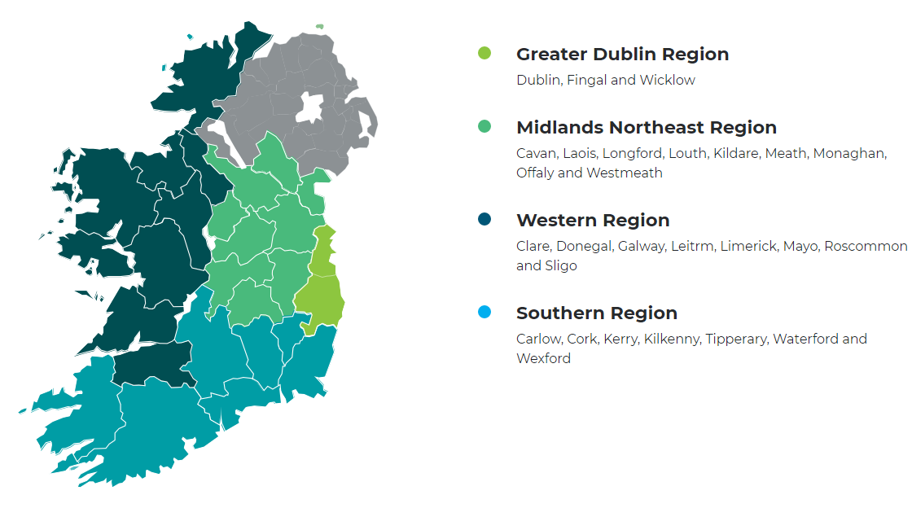

Job description

Reports to
Regional Manager

Responsibilities

Staff Support
- Provide support and supervision to Advocates in assisting, supporting and representing people with disabilities to seek a social service, negotiating on their behalf and pursuing any right of review or appeal as required.
- Mentor, coach and supervise advocates in the regional team to achieve optimum performance while maintaining a supportive working atmosphere
- Support advocates in the team to develop advocacy practice in line with national guidelines and quality standards
- Safeguard the independence of advocacy in the delivery of the advocacy service
- Monitor the team’s compliance with data protection legislation requirements
- Support the development and sharing of knowledge within the team of relevant legislation, appeals/ redress mechanisms and social policy and practices in relation to advocacy work
- Develop systems for review of cases and enquiries within the team and proactively seek to identify process improvements
- Encourage and support Advocates’ active engagement in social policy to identify and report to the Citizens Information Board on issues that arise for people we support in order to inform systemic changes in both service delivery and policy

Assist Regional Manager

- Produce, analyse and present service activity data on a regular basis.
- Undertake review and evaluation of service in conjunction with Regional Advocacy manager.
- Support the Regional Advocacy Manager in developing and reporting on measures that demonstrate the effectiveness of outcomes achieved by the service
- Assist with the allocation of staff resources to ensure the service reaches those most in need of advocacy support
- Deputise for the Regional Advocacy Manager as delegated by the National Manager or requested by the Regional Advocacy Manager
- Contribute to the development and preparation of resource and training materials to support the delivery of quality advocacy services
- Assist the Regional Advocacy Manager in the effective management of caseloads and ensure accurate records are maintained on the electronic case management system, adhering to case management requirements
- Collaborate with the Regional Advocacy Manager in the implementation of quality standards, staff training and development and service delivery initiatives
- Assist with financial planning and monitoring as required

Advocacy Practice
- Provide representative advocacy for people with disabilities particularly in complex situations
- Support people with disabilities in residential and day services to effect changes that ensure their rights, dignity, choices and decisions are safeguarded.
- Work as part of a regional team providing assistance to the Regional Advocacy Manager, supporting Advocates and sharing learning to improve practice and influence change
- Coordinate the adoption of and adherence to standardised policies, practice and quality standards within the Regional Advocacy Team
- Support the Regional Advocacy Manager in ensuring that people with disabilities who need information, advice and advocacy are provided with the service that best supports their needs and that those with the capacity to self-advocate are supported to use mainstream services in their local community.
- Develop effective and co-operative relationships with key stakeholders including service providers without compromising the independence of the advocacy service.

Additional Duties and Responsibilities
- Liaise with other support agencies in the region and build effective stakeholder relationships
- Undertake promotional work on the National Advocacy Service as directed by the Regional Advocacy Manager
- Undertake appropriate training as required and ensure continuing professional development
- Undertake supervision of practice in line with service requirements
- Represent the National Advocacy Service for People with Disabilities at conferences etc. as decided by the Regional Advocacy Manager
- Participate in special projects and joint working arrangements in consultation with the Regional Advocacy Manager
- Participate and work within a Performance Management Development System (PMDS) process
- Attend centres within the region when required to offer support with specific cases
- Undertake other duties assigned by the Regional Advocacy Manager

Person specification

Minimum Educational Qualifications & Experience
- Educated to graduate level in one or more of the following areas: social sciences, humanities, law, training and development. Equivalent experience and training will also be considered.
- Advocacy qualification desirable

Essential Knowledge & Skills

- Previous experience in a staff supervision/support / mentoring role
- Experience of staff coaching and training
- Previous experience of working with people in a service delivery role
- Knowledge of relevant disability legislation, disability rights and issues, developments in disability services
- Effective communication skills both oral and written
- Ability to impart knowledge
- Ability to negotiate effectively on behalf of people we work with.
- Good IT skills
- Good written English
- Experience of and commitment to building up personal skills
- Case management skills
- Ability to give presentations to a variety of audiences.
- Ability to monitor, review, analyse and evaluate projects

Required Competencies

NAS operates a competency based application and interview process, however there may be skills testing or a presentation involved in latter stages (this will be made known to those shortlisted).
The application form will ask you to write about your experiences in your career to date under several competencies and indicators. Use the below indicators to help you shape your responses, ensuring you clearly list employers (if applicable) and times of the experiences.

Competency | Indicator (not exhaustive)
- 1. Coaching/Mentoring | - Ability to engage in reflective practice with staff  - Enable staff to discern areas for development;  - Examples of Transfer skills/expertise
- 2. Supporting Staff | - Ability to engage with staff;  - Monitor individuals’ workloads and capability,  - Identify pressured situations and seek and apply appropriate solutions
- 3. Ability to advocate on behalf of people with disabilities | - Evidence of awareness of current disability sector and developments underway or under consideration in the sector.  - Understanding of principles of advocating on behalf of others  - Demonstration of Negotiation skills, Problem Solving, planning and analysis skills
- 4. Ability to monitor, review, analyse and evaluate | - Identify and collect relevant data;  - Examine the data;  - Identify factors indicating effectiveness or otherwise of service;  - Make recommendations on basis of analysis and evaluation.
- 5. Ability to identify social policy issues | - Through knowledge of disability legislation and issues faced by individuals;  - Identify anomalies and suggest solutions and present issues in various formats.
6. Drive & Commitment to NAS Core Values | • Can demonstrate commitment to values similar or the same as the NAS Core Values of Independence, Autonomy, Equality/Citizenship, Respect and Empowerment (see page 4) in personal and/or professional life.  • Ensures the citizen is at the heart of all services provided.  • Is personally honest and trustworthy and can be relied upon.  • Through leading by example, fosters the highest standards of ethics and integrity.

Terms & Conditions

Full Time, Specified Purpose Contract Senior Advocate Role to cover a career break.

Salary

€47,675-53,022

It is expected, that all new entrants to NAS will be appointed at point one of the salary scale, however the NAS operates an incremental credit process for appointments higher than point one. This process is applicable to new entrants into NAS. Incremental credit criteria, based on the competencies for the role, are assessed against employment history as laid out in the application form only. A request for incremental credit from a successful candidate must be made within the first 3 months of employment.

Location
Dublin covering Dublin and Wicklow

Pension
A company pension scheme is in place, and membership is obligatory upon commencement. Employee contribution; 5% of salary, Employer contribution; 7% of salary. NAS has a normal retirement age linked to the State Pension Age (currently 66).

Annual Leave
24 days per leave year (January to December)

Requirements
- The position entails some travel; therefore access to use of a car is a requirement for the post.
- The Senior Advocate will be asked to obtain Garda Clearance before they begin work.

How to Apply

- A relevant application form can be accessed at www.advocacy.ie
- Applicants must meet the minimum criteria for the role set out in the person specification and possess all required competencies and will be shortlisted solely on the basis of information provided in their completed application form.
- Curriculum Vitae (CVs), late, incomplete or hand-written applications will not be considered.
- Please contact recruitment@advocacy.ie if you have any special requirements in relation to completing the application form.
- Closing date: Monday 12th December @ 5.00pm
- Please email application form to: recruitment@advocacy.ie and place Reference SAGDROCT22 in the subject line.
- Please Note that this is a re-advertisement – previous applicants do not need to reapply.
- A panel of qualified candidates may be formed from which Senior Advocate posts which arise in a specified period, up to a maximum of 12 months, will be filled.
- For information on how your personal data will be used as part of this process please refer to our Data Protection Notice for Job Applicants, available at the following link:

https://www.citizensinformationboard.ie/en/data_protection/nas.html

National Advocacy Service for People with Disabilities is an equal opportunities employers.

