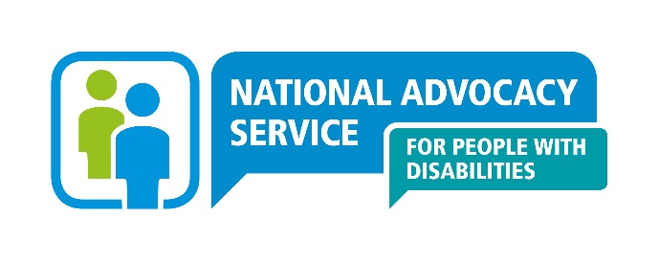

**Enquiry Line: *0818 07 3000***

**Self Enquiry Form**

|  |  |  |  |  |  |  |  |  |
| --- | --- | --- | --- | --- | --- | --- | --- | --- |
| **The National Advocacy Service for People with Disabilities provides an independent, confidential and free, representative advocacy service that puts the person at the centre and adheres to the highest professional standards nationally.** | | | | | | | | |
| **If you would prefer to talk to an advocate directly please contact us by phone or e-mail, rather than completing this form.**  **However, if you would like to provide your information in written format please complete this form and we will be in touch.** | | | | | | | | |
| **YOUR DETAILS:** | | | | | | | | |
| **Name:** |  | | | | | | | |
| **AGE** | **Under 18 18 – 65 65 +** | | | | | | | |
| **Gender:** | **M** |  | **F** | |  | |
| **Address:** | | |  | | | | | |
| **Telephone:** | | |  | | | | | |
| **E-Mail:** | | |  | | | | | |
| **We need your information to know if we are the right service for you.**  **Please answer the following questions.** | | | | | | | | |
|  | | | | | | | | |
| **WHAT WOULD YOU LIKE THE ADVOCATE TO SUPPORT YOU WITH ?** | | | | | | | | |
|  | | | | | | | | |
| **HAS ANYONE ELSE SUPPORTED YOU WITH THIS ?**  **(*this might be family member / friend / social worker / GP or anyone else)*** | | | | | | | | |
|  | | | | | | | | |
| **IF YOU WOULD LIKE TO TELL US SOMETHING ABOUT YOUR DISABILITY, PLEASE DO SO BELOW;** | | | | | | | | |
|  | | | | | | | | |
| **PLEASE USE THE SPACE BELOW TO ADD ANYTHING ELSE YOU FEEL IS OF IMPORTANCE**  ***(i.e. are there specific days of the week or times of the day when it is easier to contact you to arrange a first meeting or any important dates coming up)*** | | | | | | | | |
|  | | | | | | | | |
| **HOW WOULD YOU LIKE US TO CONTACT YOU ?** | | | | | | | | |
| Telephone | | | |  | | E-Mail | |  |
| Face to Face | | | |  | | SLIS / IRIS | |  |
| Skype / Facetime | | | |  | | Other | |  |
| Is there anything else you would like to let us know about contacting you? | | | | | | | | |
|  | | | | | | | | |
| *We will keep your information confidential. There are some occasions when an advocate will have to give your personal information without your agreement. This will be if:*   1. *you are in danger,* 2. *you are a danger to someone else* 3. *a court order asks for your information* 4. *a child is in danger of abuse* | | | | | | | | |
| **YOU CAN RETURN THIS FORM BY POST TO THE ADDRESS ON**  **THE FRONT OF THIS FORM** | | | | | | | | |

**________________________________ _______________________________**

**SIGNATURE DATE**

|  |
| --- |
| **SENDING FORM BY E-MAIL** |

**Please send this form to the regional office address that covers the county that you live in:**

|  |  |
| --- | --- |
| **Greater Dublin**  Dublin, Fingal and Wicklow. | pearl.malone@advocacy.ie |
| **Midlands, Northeast**  Kildare, Meath, Cavan, Laois, Longford, Louth, Monaghan, Offaly, Westmeath. | mandy.price@advocacy.ie |
| **Western**  Clare, Donegal, Galway, Leitrim, Limerick, Mayo, Roscommon, Sligo. | bronwyn.keegan@advocacy.ie |
| **Southern**  Carlow, Cork, Kerry, Kilkenny, Tipperary, Waterford, Wexford. | annemarie.collins@advocacy.ie |