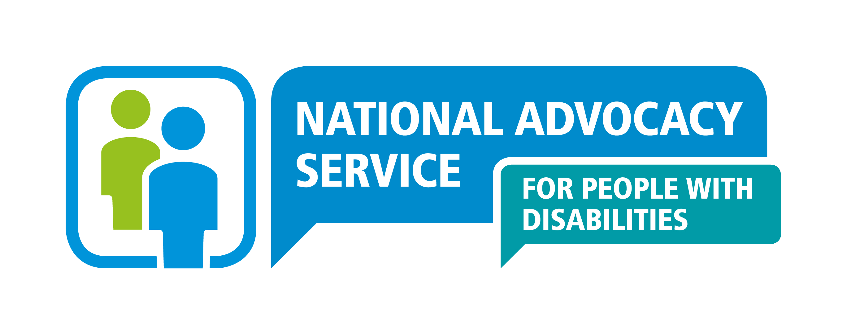
((

Enquiry Form

PLEASE ONLY COMPLETE THIS FORM IF YOU ARE MAKING AN ENQUIRY ON BEHALF OF ANOTHER PERSON

Enquiry Line: 0818 07 3000

ENQUIRY
Does the person know that you are contacting NAS on their behalf?  (NAS is led by the person, and where possible requires their direct instruction to begin working with them.) |  |  |  |  | Yes No
If not, please explain:

Can the person speak to NAS directly rather than this enquiry form being completed on their behalf? |  |  |  |  | Yes No
Has the person given their explicit consent to you for their personal information to be shared? |  |  |  |  | Yes No
Date consent obtained: |  |  |  | By whom:
If no, is the enquiry necessary to protect vital interests of the person?  If no, is the enquiry necessary for public interest or official authority?  If no, any other explanation: |  |  |  |  | Yes No  Yes No
PERSON’S DETAILS
Name:
Address:

REASON FOR ENQUIRY:
What are the Advocacy Issues?
(Please note NAS provides one to one representative advocacy for adults only (18+) and works on an issue specific basis. NAS do not offer long term social support or other services such as key working, social work or legal services).

What steps have you taken to support the person with these Issues?

SIGNIFICANT OTHERS (i.e. Friends and Family - name and contact details (Where relevant):
Any steps taken by significant others to support the person with these issues?

OTHER PROFESSIONALS INVOLVED (name and contact details where relevant):
Please indicate if they are aware of the advocacy issues identified and what steps they have taken to support the person with these issues:

NATURE OF PERSON’S DISABILITY
Intellectual Disability |  |  | Dementia
Autism Spectrum Disorder |  |  | Acquired Brain Injury
Mental Health |  |  | Sensory Disability
Physical Disability |  |  | Other (please state below)
PRIMARY MEANS OF COMMUNICATION
Verbal |  |  | Gestures / Facial Expressions / Vocalisations
Other Spoken Language |  |  | No Obvious Means of Communication
Sign Language |  |  | Other (please state below)
Words / Pictures – Picture Bank

ENQUIRERS DETAILS
Name:
Position/Relationship to person:
Address:

Telephone Number and Email:
PLEASE USE THE SPACE BELOW TO ADD ANYTHING ELSE YOU FEEL IS OF IMPORTANCE
(i.e. are there specific days of the week or times of the day when it is easier to contact the person to arrange a first visit, should the advocate contact the enquirer to arrange a first visit etc.)

Other Essential Information:

Has the person given permission for an Advocate to contact them? |  | Yes | No
Person’s contact details (if appropriate):
If person resides in a residential setting, is this enquiry being made following a HIQA inspection? |  | Yes | No

PLEASE BE AWARE THAT UPON RECEIPT OF THIS ENQUIRY THE NATIONAL ADVOCACY SERVICE FOR PEOPLE WITH DISABILITIES IS CONFIDENTIAL, AND THEREFORE THE NATIONAL ADVOCACY SERVICE FOR PEOPLE WITH DISABILTIIES WILL ONLY HAVE FURTHER CONTACT WITH YOU UNDER THE SPECIFIC AUTHORITY OF THE PERSON OR WHERE NECESSARY.
PLEASE NOTE THAT COMPLETION OF THIS FORM DOES NOT AUTOMATICALLY RESULT IN AN ADVOCATE BEING APPOINTED FOR THE PERSON. THIS FORM IS PART OF AN ENQUIRY PROCESS TO DETERMINE WHETHER OR NOT NAS IS THE RIGHT SERVICE FOR THE PERSON.

Please note this enquiry can only be processed if every section of this form has been completed.
Incomplete forms will be returned

SIGNATURE: _______________________________ DATE: _______________________

SENDING FORM BY E-MAIL
Please send this form to the regional office address that covers the county in which the person lives;

Greater Dublin  Dublin, Fingal and Wicklow. | pearl.malone@advocacy.ie
Midlands, Northeast  Kildare, Meath, Cavan, Laois, Longford, Louth, Monaghan, Offaly, Westmeath. | mandy.price@advocacy.ie
Western  Clare, Donegal, Galway, Leitrim, Limerick, Mayo, Roscommon, Sligo. | bronwyn.keegan@advocacy.ie
Southern  Carlow, Cork, Kerry, Kilkenny, Tipperary, Waterford, Wexford. | annemarie.collins@advocacy.ie

