

**Policy, Communications & Research Officer**

**(Full-Time, Temporary to 31 December 2025)**

**Candidate Pack**

**June 2025**

Contents

NAS - What we do 3

Our Core Values 4

Regional layout & locations 5

Job description 6

Reports to 6

Nature & Scope 6

Responsibilities 6

Person specification 8

Minimum Educational Qualifications & Experience 8

Essential Knowledge & Skills 8

Desirable Knowledge & Skills 8

Required Competencies 9

Terms & Conditions 11

Salary 11

Pension 11

Annual Leave 11

Requirements 11

How to Apply 12

# NAS - What we do

The National Advocacy Service for People with Disabilities (NAS) provides an independent, confidential and free, issues-based representative advocacy service.

We provide representative advocacy to people with disabilities, to ensure that their will and preferences are heard in decisions that affect their lives, in areas that include social services, health, accommodation, personal finances, legal issues and family and relationships.

We have a particular remit to work with people with disabilities who; live in residential services, live in inappropriate accommodation, attend day services, have communication differences, have limited natural supports or are isolated from their communities.

The National Advocacy Service for People with Disabilities is funded and supported by the Citizens Information Board (CIB) which has a mandate under the Citizens Information Act 2007 and Comhairle Act 2000 to support the provision of advocacy for people with disabilities.

The Patient Advocacy Service is provided under the auspices of the National Advocacy Service for People with Disabilities and was established in October 2019 following the awarding of the contract a competitive tendering process to NAS in 2018. The Patient Advocacy Service is an independent, free and confidential Service that provides information and support to people who want to make a complaint about an experience they have had in an HSE-funded public acute hospital, and in the aftermath of patient safety incidents.

A national office team support service development and corporate governance for both services. The successful candidate will work alongside the Patient Advocacy Service Communications Officer to support the continuing development of high-quality advocacy services.

The successful candidate will be expected to effectively network, build relationships and engage with and influence stakeholders at all levels of seniority and to apply judgement and flexibility in a challenging and fast-moving environment.

This is an excellent opportunity for a suitably qualified individual to shape policy and communications within the National Advocacy Service for People with Disabilities.

# Our Core Values

Our Strategic Plan 2018-2021 establishes the following five Core Values that underpin the work of NAS and the Patient Advocacy Service.

|  |
| --- |
| 1. Independence   We work with the person independently of others and free from all conflicts of interest. The advocacy process is led and guided by the person. |
| 1. Autonomy   We support the right of the person to self-direction/ determination (i.e. to be in control of their own life) and to make informed decisions based on their will and preferences. We also empower people to have their complaints processed in a balanced, fair and transparent manner. |
| 1. Equality/Citizenship   We support the right of every person to assert and enjoy their human rights, to participate in society as an equal citizen and to fulfil their full potential within a life of their own choosing. |
| 1. Respect   We work with the person in a way which demonstrates respect for the person as an individual and for their privacy, dignity and autonomy. All staff, partners and directors of NAS and the Patient Advocacy Service will act in a way that demonstrates respect for the people who use our services and each other.   1. Empowerment   We aim to facilitate the person to be an active participant in decisions which affect their life, through the way in which the advocacy process is carried out as well as the outcomes it seeks to achieve. We also aim to empower the person to make a complaint or engage with a review process and seek answers when things go wrong.  Are you interested in supporting these core values and communicating and developing projects and activities which will assist in supporting the rights of people accessing health and social services? Read further regarding the role, job description and required competencies |

# Regional layout & locations

NAS operates across 31 locations throughout Ireland and share premises with the Citizens Information Service (13), Money Advice and Budgeting Service (1), the Citizens Information Board (4) and others (13). This co-location enhances the referral of people between services.

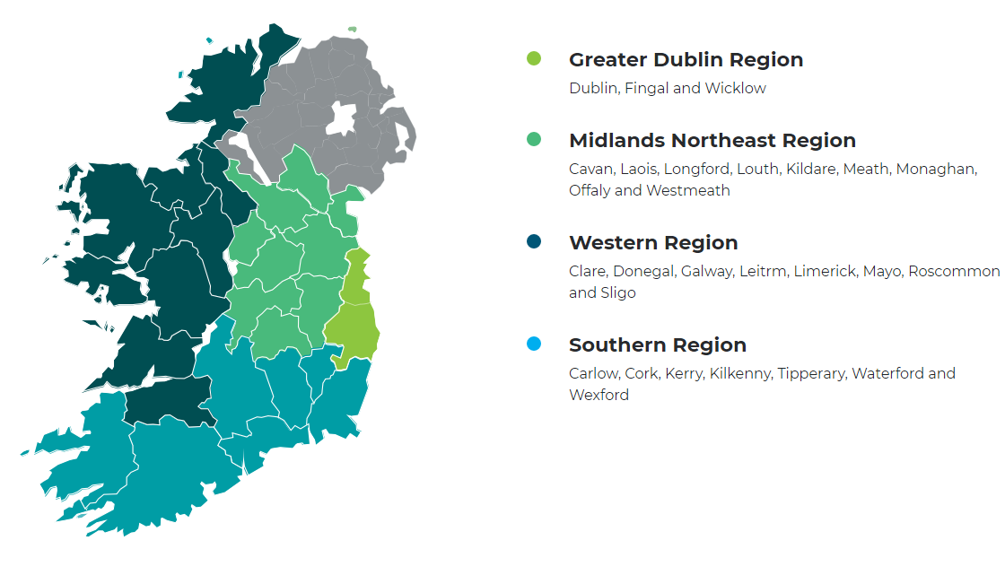

# Job description

## Reports to

National Manager

## Nature & Scope

The Policy, Communication and Research Officer will support, promote and develop information on the effectiveness of current social policy and services, highlight issues that are of concern to users of those services and develop policy feedback and prepare reports and submissions in this area.

## Responsibilities

Policy & Research

* Develop regular policy submissions on behalf of the organisation in line with service user, funder and other stakeholder requirements.
* Represent the organisation’s and NAS users’ interests through responding to public consultations and participating in public and stakeholder engagements.
* Develop and implement internal and external feedback mechanisms to share NAS’s contribution to the development of relevant social policy.
* Develop NAS’s organisational capacity to contribute to the progression of social policy in the areas relevant to their stakeholders.
* Develop NAS’s regional capacity to engage in social policy work with organisations at local level, including the provision of social policy training to NAS Advocates.
* Organise seminars and conferences on social policy matters as required and promote NAS’s social policy output to all relevant fora.
* Act as a subject matter expert and key point of contact for policy, research and communications matters.
* Responsible for the co-ordination and delivery of a programme of policy research which may include commissioning and conducting research projects, writing reports and the dissemination of findings and publications as appropriate.
* Undertake desk and field research as required.
* Collect, collate and analyse quantitative and qualitative data relating to policy matters from NAS staff, service users and other relevant sources.
* Collaborate with CIB and other stakeholders on research of interest to NAS

Communications

* Assist the National Manager in the timely and accurate completion of responses to Parliamentary Questions as required.
* Manage the day-to-day internal and external communications activities of NAS.
* Co-ordinate media and public affairs activities to promote NAS’s legal and policy positions.
* Manage the monitoring of media and current affairs for NAS.
* Develop and maintain a strong brand for the organisation, including impactful and effective publications, web site content and social media material.
* Prepare press statements and articles on advocacy rights issues for internal and external communications.
* Prepare speeches for the National Manager and other senior team members as required.
* Manage the publication and promotion of NAS promotional materials as well as the organisation’s annual report, including design and printing.
* Ensure that NAS communication outputs are of a high standard, respond to the needs of the target audience, and are delivered within agreed budget and timelines.
* Build on existing and develop relationships with media, key decision makers, relevant organisations and others.
* Represent and promote the organisation, attend and participate at conferences and seminars as agreed.

General

* This role may require the management and/or supervision of staff.
* Contribute to the development of annual work plan and strategic planning as required.
* Participate in special projects and joint working arrangements, including taking a lead role in the management of projects and budgets, in consultation with the National Manager.
* Provide support for sub-committees of the Board of Directors as required
* Participate in training and development programmes/courses to maintain and improve performance and to assist in identifying personal training and support needs.
* Contribute to the ongoing development of the organisation.
* Undertake such other duties as agreed with the National Manager.

# Person specification

## Minimum Educational Qualifications & Experience

* Educated to graduate level in social sciences, humanities, law, public relations or communications
* Experience (minimum 2 years) of working in a policy and/or communications role

## Essential Knowledge & Skills

* A good understanding of current policy issues affecting the disability/advocacy sector.
* Experience of drafting and publishing accurate copy.
* Experience of influencing policy makers.
* Experience of making presentations to a variety of audiences.
* Ability to manage the day-to-day internal and external communications and marketing activities.
* Experience in organising internal and external events
* Excellent interpersonal, communications and relationship management skills.
* Ability to work with MS Word/Excel/PowerPoint/Wordpress and social media applications.
* Excellent organisational skills.
* Self-motivated and able to take initiative to deliver tasks.
* Able to work with a team.
* Willing to learn and develop in the role.

## Desirable Knowledge & Skills

* Experience of public speaking.
* Experiencing managing or contributing to the delivery of successful events.

# Required Competencies

NAS operates a competency-based application and interview process, however there may be skills testing or a presentation involved in latter stages (this will be made known to those shortlisted).

The application form will ask you to write about your experiences in your career to date under several competencies and indicators. Use the below indicators to help you shape your responses, ensuring you clearly list employers (if applicable) and times of the experiences.

|  |  |
| --- | --- |
| Competency | Indicator (not exhaustive) |
| 1. Specialist knowledge &  Self-Development | * Evidence of awareness of current disability sector and developments underway or under consideration in the sector. * Develops and maintains skills and expertise to perform the role effectively e.g. relevant software and IT systems, organisational policies & procedures and the relevant legislative, policy and regulatory framework. * Constantly learns from experience and takes the initiative to develop new skills and expertise through research, learning and training. * Shares work-related knowledge and expertise with colleagues. |
| 2. Effective Communication & Interpersonal Skills | * Ability to explain, advocate and express facts and ideas in a convincing way. * Expresses self clearly and confidently in both written (email/letter) and oral communication (telephone/in person). * Presents information to all stakeholders in a clear and confident manner. * Builds and maintains good working relationships with colleagues and other external stakeholders. |
| 3. Analysis & Decision Making | * Effectively deals with a wide range of information sources, investigating all relevant issues. * Draws accurate conclusions & makes balanced and fair recommendations backed up with evidence. * Identifies gaps or anomalies in social policy and assists with the preparation of reports and submissions. * Ability to conduct strategic analysis. |
| 4. Planning & Organisation | * Demonstrates efficient use of own time and maximises resources available to them. * Has demonstrated ability to successfully plan and organise events. * Establishes realistic milestones, reviews progress and adjusts accordingly * Is flexible and is adaptable to changing circumstances |

|  |  |
| --- | --- |
| Competency (continued) | Indicator (not exhaustive) |
| 5. Teamwork & Collaboration | * Ability to work co-operatively within a group and to achieve goals in a respectful manner. * Understands and is tolerant of differing needs and viewpoints. * Works well with all stakeholders, both internal and external. * Actively helps and supports others to achieve team goals. |
| 6. Drive & Commitment to NAS Core Values | * Can demonstrate commitment to values similar or the same as the NAS Core Values of Independence, Autonomy, Equality/Citizenship, Respect and Empowerment (see page 4) in personal and/or professional life. * Ensures the citizen is at the heart of all services provided. * Is personally honest and trustworthy and can be relied upon. * Through leading by example, fosters the highest standards of ethics and integrity. |

# Terms & Conditions

## Salary

€38,773 to €52,302 (including long service increment).

It is expected that all new entrants to NAS will be appointed at point one of the salary scales, however the NAS operates an incremental credit process for appointments higher than point one. This process is applicable to new entrants into NAS. Incremental credit criteria, based on the competencies for the role, are assessed against employment history as laid out in the application form only. A request for incremental credit from a successful candidate must be made within the first 3 months of employment.

## Pension

A company pension scheme is in place, and membership is obligatory upon commencement. Employee contribution; 5% of salary, Employer contribution; 7% of salary. NAS has a normal retirement age linked to the State Pension Age (currently 66).

## Annual Leave

24 days. After 2 years 25 days. After 5 years 26 days (January to December)

## Requirements

* The position entails some travel; therefore, access to use of a car is a requirement for the post.
* The Policy, Communications & Research Officer will be asked to obtain Garda Clearance before they begin work.

# How to Apply

* A relevant application form can be accessed at [www.advocacy.ie](http://www.advocacy.ie)
* Applicants must meet the minimum criteria for the role set out in the person specification and possess all required competencies and will be shortlisted solely on the basis of information provided in their completed application form.
* Curriculum Vitae (CVs), late, incomplete or hand-written applications ***will not*** be considered.
* Please contact **Karen Horan** at the email address belowif you have any special requirements in relation to completing the application form.
* **Closing date:** 12 p.m. on Thursday, 17th July 2025.
* **Please email application form to:** [karen.horan@advocacy.ie](mailto:karen.horan@advocacy.ie) stating ‘NAS Policy Communications & Research Officer 2025’ in the subject line
* Successful applicants may be required to complete an assessment on the day of interview, which may be an IT or written skills test, case study and or presentation, you will be advised in advance.
* A panel of qualified candidates may be formed from which temporary, full-time PCRO posts which arise in a specified period, up to a maximum of 12 months, will be filled.
* For information on how your personal data will be used as part of this process please refer to our Data Protection Notice for Job Applicants, available at the following link:

[***https://www.citizensinformationboard.ie/en/data_protection/cib.html***](https://www.citizensinformationboard.ie/en/data_protection/cib.html)

***The National Advocacy Service for People with Disabilities is an equal opportunities employer.***