Citizens Information Board Digital Strategy Survey
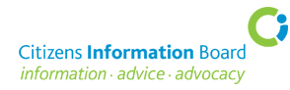 | The Citizens Information Board supports information provision and advocacy in Ireland.
 | They do this by funding 22 companies including Citizens Information Service, the National Advocacy Service and others.
 | Citizens Information Board want to make a plan on how to engage with people online as well as how they already meet people in person. This is called a Digital Strategy.
 | Citizens Information Board want to know what you think about online support. You can let them know what you think by taking an online survey.
 | The survey is short and should only take you 5 minutes to complete.
 | If you want to take part, this online survey is open until February 21st.
 | Some people might need help to complete the survey or want to find out more about it before doing it. A friend or support worker could help you.
 | If you want to find out more or need help to complete this survey, contact charlotte.olhausen@advocacy.ie

