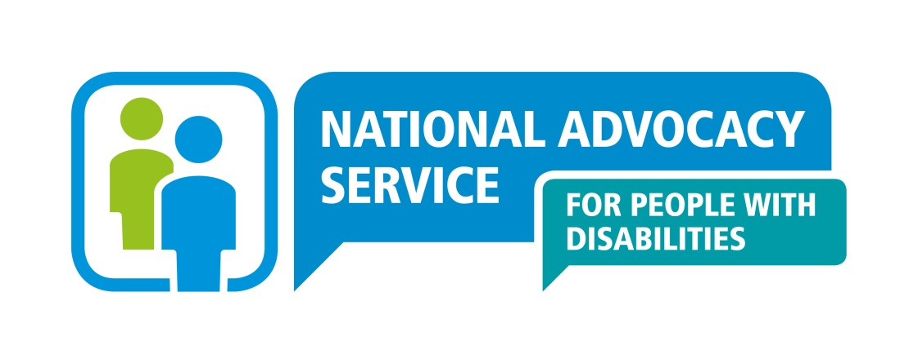

**National Advocacy Service for People with Disabilities**

**Application form: Senior Advocate Recruitment**

CONFIDENTIAL APPLICATION FOR EMPLOYMENT

|  |  |
| --- | --- |
| POSITION DETAILS |  |
| Title of Post | **Senior Advocate, National Advocacy Service for People with Disabilities** |
| Location | **Southern Region - Cork** |

It is anticipated that new entrants to the National Advocacy Service will be appointed on the 1st point of the scale however, incremental credit, should it be awarded, will be based on previous relevant experience as set out on application form.

|  |  |
| --- | --- |
| **PERSONAL DETAILS (use BLOCK LETTERS)** | |
| Surname | Given Names |
| Address for correspondence | |
| Contact details: Home Business  Mobile Email | |
| Do you own or have the access to use of a car? Yes ___ No ___ | |
| Do you / Does the driver hold a full driving licence? Yes / No | |

|  |  |  |
| --- | --- | --- |
| **EDUCATIONAL QUALIFICATIONS** | | |
| Title of Award / Awarding Body | University / College / School | Final Examination Subjects & Results |
|  |  |  |
|  |  |  |
|  |  |  |

Please list below any courses/training undertaken in the past three years to maintain your skills:

|  |
| --- |
| **PROFESSIONAL MEMBERSHIPS / ASSOCIATIONS (if any)** |
|  |
| **COMMUNITY / VOLUNTARY EXPERIENCE (if any)** |
|  |

|  |  |  |  |  |
| --- | --- | --- | --- | --- |
| **PREVIOUS EMPLOYMENT** (please provide your full employment history) | | | | |
| **Employer** | **Date from** | **Date to** | **Position Held / Main Duties and Responsibilities** | **Key Achievements** |
|  |  |  |  |  |
|  |  |  |  |  |
|  |  |  |  |  |

|  |  |  |  |  |
| --- | --- | --- | --- | --- |
| **INFORMATION TECHNOLOGY – Please tick √ as appropriate** | | | | |
| **Software Package** | **No Knowledge** | **Limited Familiarity** | **Extensive use in Work** | **Qualification / Award** |
| Microsoft Word |  |  |  |  |
| Microsoft Excel |  |  |  |  |
| Microsoft Access |  |  |  |  |
| Microsoft Powerpoint |  |  |  |  |
| Outlook |  |  |  |  |
| Other (specify |  |  |  |  |

Have you used an electronic case management system? Yes No Delete as appropriate

**For each of the competency areas below, briefly highlight specific achievements, contributions or expertise you have developed from your career to date, which demonstrate your suitability to meet the challenges of this role. Use the definition of the competencies in the candidate pack to assist you (maximum 300 words per section). Please note employers/roles in which you worked in at the time.**

|  |  |
| --- | --- |
| 1. **Coaching/Mentoring** |  |
| 1. **Supporting Staff** |  |
| 1. **Ability to advocate on behalf of people with disabilities** |  |
| 1. **Ability to monitor, review, analyse and evaluate** |  |
| 1. **Ability to identify social policy issues** |  |
| 1. **Drive & Commitment to NAS Core Values** |  |

|  |  |  |  |
| --- | --- | --- | --- |
| **REFEREE INFORMATION (please list three persons, including current employer)** | | | |
| Name | Full Postal Address | Professional Relationship to you | Contact details |
|  |  |  | Phone:  Email: |
|  |  |  | Phone:  Email: |
|  |  |  | Phone:  Email: |
| Do you require notification before your referees are contacted? Yes / No | | | |

|  |
| --- |
| **APPLICANT DECLARATION** |
| *I declare to the best of my knowledge and belief, all particulars I have given are complete and true. I understand that any false declaration, misleading statement or significant omission may disqualify me from employment and render me liable to dismissal. I understand information contained in this application will be verified by the National Advocacy Service for People with Disabilities and that any job offer is subject to references and a probationary period both of which must be deemed satisfactory by the organisation.*  **NAME : DATE :** |

**Completed application and a covering letter must be submitted no later than 5pm on Monday, 3rd March 2025.**

**The completed application form and a covering letter should be emailed (as an attachment) to** [recruitment@advocacy.ie](mailto:recruitment@advocacy.ie) **(stating SENIORADVOCATECORK2502 in the subject line)**

**Receipt of your application form will be acknowledged by email by NAS. Late or incomplete applications will not be accepted.**

**Data Protection**

All personal information provided on this application form will be stored securely by the National Advocacy Service for People with Disabilities and will be used for the purposes of the recruitment process. Application forms will be retained for a period of 18 months, and in the case of a successful candidate, for the duration of employment and a minimum of one year thereafter. The information contained will not be disclosed to any external party unconnected with this recruitment process without your consent, except where necessary to comply with statutory requirements. Internally, the information may be made available to the relevant Line Manager, members of the Board of the National Advocacy Service and to the Shortlisting/Interviewing Panel. You may, at any time, make a request for access to the information held about you as outlined. Should you wish to make any changes, or erasures to any of the information stored about you please contact The National Manager, National Advocacy Service for People with Disabilities, National Office, Level 3 Rear Unit, Marshalsea Court, Merchant's Quay, Dublin 8.