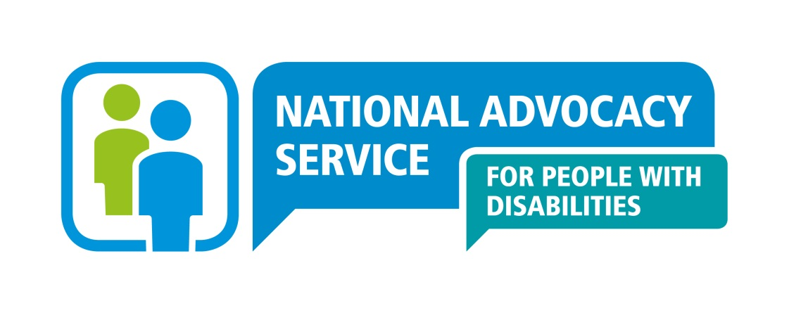

National Advocacy Service for People with Disabilities

Application form: Senior Advocate Recruitment

CONFIDENTIAL APPLICATION FOR EMPLOYMENT

POSITION DETAILS
Title of Post | Senior Advocate (Full time, temporary, fixed term contract), National Advocacy Service for People with Disabilities
Location | Roscommon Town, Co Roscommon, Western Region

Incremental Credit: It is expected, that all new entrants to NAS will be appointed at point one of the salary scale. However, NAS operates an incremental credit process for appointments higher than point one. This process is applicable to new entrants into NAS.Incremental credit criteria, based on the competencies for the role, are assessed against employment history as laid out in the application form only. A request for incremental credit from a successful candidate must be made within the first 3 months of employment. The decision on whether or not to award an incremental credit is a decision made by the Board and is subject to the availability of funding.

PERSONAL DETAILS (use BLOCK LETTERS)
Surname | Given Names
Address for correspondence

Contact details: Home Business
Mobile Email
Do you own or have the access to use of a car? Yes ___ No ___
Do you / Does the driver hold a full driving licence? Yes / No

EDUCATIONAL QUALIFICATIONS
Title of Award / Awarding Body | University / College / School | Final Examination Subjects & Results

Please list below any courses/training undertaken in the past three years to maintain your skills:

PROFESSIONAL MEMBERSHIPS / ASSOCIATIONS (if any)
COMMUNITY / VOLUNTARY EXPERIENCE (if any)

PREVIOUS EMPLOYMENT (please provide your full employment history)
Employer | Date from | Date to | Position Held / Main Duties and Responsibilities | Key Achievements

INFORMATION TECHNOLOGY – Please tick √ as appropriate
Software Package | No Knowledge | Limited Familiarity | Extensive use in Work | Qualification / Award
Microsoft Word
Microsoft Excel
Microsoft Access
Microsoft Powerpoint
Outlook
Other (specify

Have you used an electronic case management system? Yes No Delete as appropriate

For each of the competency areas below, briefly highlight specific achievements, contributions or expertise you have developed from your career to date, which demonstrate your suitability to meet the challenges of this role. Use the definition of the competencies in the candidate pack to assist you (maximum 300 words per section). Please note employers/roles in which you worked in at the time.

- Coaching/Mentoring

- Supporting Staff

- Ability to advocate on behalf of people with disabilities

- Ability to monitor, review, analyse and evaluate
- Ability to identify social policy issues
- Drive & Commitment to NAS Core Values

REFEREE INFORMATION (please list three persons, including current employer)
Name | Full Postal Address | Professional Relationship to you | Contact details
Phone:
Email:
Phone:
Email:
Phone:
Email:
Do you require notification before your referees are contacted? Yes / No

APPLICANT DECLARATION
I declare to the best of my knowledge and belief; all particulars I have given are complete and true. I understand that any false declaration, misleading statement or significant omission may disqualify me from employment and render me liable to dismissal. I understand information contained in this application will be verified by the National Advocacy Service for People with Disabilities and that any job offer is subject to references and a probationary period both of which must be deemed satisfactory by the organisation.

NAME : DATE:

Completed application and a covering letter must be submitted no later than 5pm on Monday 29th September 2025

The completed application form and a covering letter should be emailed (as an attachment) to recruitment@advocacy.ie (stating Reference number ‘2025SAWEST’ in the subject line)

Receipt of your application form will be acknowledged by email by NAS. Late or incomplete applications will not be accepted.

Data Protection
All personal information provided on this application form will be stored securely by the National Advocacy Service for People with Disabilities and will be used for the purposes of the recruitment process. Application forms will be retained for a period of 18 months, and in the case of a successful candidate, for the duration of employment and a minimum of one year thereafter. The information contained will not be disclosed to any external party unconnected with this recruitment process without your consent, except where necessary to comply with statutory requirements. Internally, the information may be made available to the relevant Line Manager, members of the Board of the National Advocacy Service and to the Shortlisting/Interviewing Panel. You may, at any time, make a request for access to the information held about you as outlined. Should you wish to make any changes, or erasures to any of the information stored about you please contact The National Manager, National Advocacy Service for People with Disabilities, National Office, Level 3 Rear Unit, Marshalsea Court, Merchant's Quay, Dublin 8.

